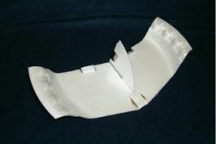
FPG-9
Styrofoam® Plate Glider

By Jack Reynolds, Volunteer, National Model Aviation Museum

Objective: This simple design requires only a foam plate, a little ambition, and even less time. The FPG-9 plane is a basic illustration of how flight works.

Description: The FPG-9 is constructed from a 9” foam plate. Just two pieces are traced from a pattern, cut out and assembled.

Materials: The materials and tools necessary are:

- FPG-9 pattern
- 9” foam plate
- Scissors
- Clear tape
- Ink pen
- Penny

How to build the FPG-9:

Note – Since a paper pattern is hard for students to trace around, the instructor may want to cut out a foam plate master template for the students to use to trace around.

1. Cut out the paper FPG-9 pattern. Do not cut along the dotted line on the paper pattern. Only cut along the bolded lines.

2. Place the paper pattern in the center of the foam plate ensuring that the tail of the pattern stays inside of the curved portion of the plate bottom. (The tail must remain on the plate’s flat bottom.) It’s fine if the tab on the front of the pattern is on the curved portion. The ends of the wings should spill over the curved edge of the plate.

SHAPE \* MERGEFORMAT 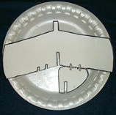

3. Trace around the pattern with an ink pen. Don’t forget to mark the scissor slits A and B.

4. Cut the foam template out by following the pen lines you just drew.

SHAPE \* MERGEFORMAT 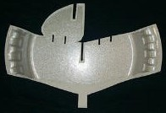

5. Once the instructor has completed the master foam template, the students may use the template to create their FPG-9 planes.

6. Have the students place the foam template in the center of the plate and trace around the template making sure to mark all of the lines.

7. When tracing slits A and B the students only need to make one line. These lines will create the elevons and rudder.

8. Have the students cut out the FPG-9 they just traced by following the pen lines.

Important Note – At this time cut along the dotted line to separate the tail from the wing of the FPG-9. It works better if you make all of your cuts from the outside of the plate towards the center of the plate. Do not try to turn your scissors to cut sharp corners. When cutting out the slots, make them only as wide as the thickness of the foam plate. If the slots are cut too wide the pieces of the plane will not fit together snuggly.

9. The wing and the tail each have slits drawn on them. Have the students make a cut along each of these lines as drawn.

10. To attach the tail to the wing, slide Slot 1 into Slot 2. Use two small (2”) pieces of tape to secure the bottom of the tail to the bottom of the wing. Ensure the tail is perpendicular to the wing before adding the tape.

11. In order to make the plane fly successfully, the students must attach a penny on top of the wing right behind the square tab. Fold the tab back over the penny and tape it down to secure the coin.

12. Bend the elevons on the wing upward. This will provide for a flatter glide. If the students want the plane to turn they can adjust the rudder on the vertical fin.

13. Your FPG-9 is complete and ready to fly. Gently toss the plane directly in front of you. Once it flies reasonably straight ahead and glides well, try throwing it hard with the nose of the glider pointed 30° above the horizon. The FPG-9 should perform a big loop and have enough speed for a glide of 20 – 25 feet after the loop.

